House to Home Fund

Available to all people supported by Style Acre who live in Supported Living or on their own in the community to apply for money to buy household items they are unable to buy themselves.

If you have any questions, please speak to or email:
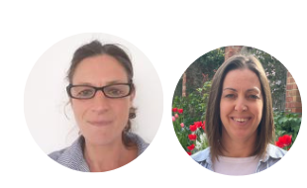
Bev Segesdy - bsegesdy@styleacre.org.uk
Anne-Marie Hicks - amhicks@styleacre.org.uk

Please tell us what it is you need for your home and why?
Please add links to the items online where possible or details of the make model and price.
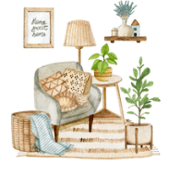

Please give or e-mail your form to
Bev Segesdy bsegesdy@styleacre.org.uk or
Anne-Marie Hicks amhicks@styleacre.org.uk



If you are paying some money towards the costs, please tell us how much this is?


If you need help to pay for this, how much would you need?

Further information
- Applications will be reviewed once a month, and everyone will get feedback as to whether they have been successful or not.
- Only those supported by Style Acre in supported living or who live on their own and are supported by Style Acre in the community can apply.
- Applications can be made by individuals or by 2 or more people living in the house.
- We may want to speak to you to find out more information.
- If you have been successful you cannot apply again for another 12 months.

