I found this – although it’s aimed at children there are lots of lovely ideas for getting people involved in the story. Have fun Michelle (SLT) Aug 2020

Alice in Wonderland Sensory story
Posted on October 20, 2013 by jd785
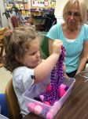We had such a great time this week exploring the classic story of Alice in Wonderland. Cara’s book was wonderful and it was so exciting for our students to see themselves in her book! Hope you enjoy seeing how we made Alice’s adventures a multi-sensory learning experience!

SENSORY GROUP
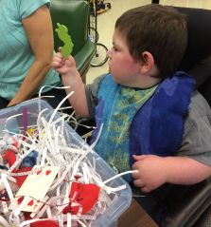Our first box was filled with paper shred since most books are made from paper—or at least they used to be
Nestled among the paper were some playing cards (hearts of course), some Mad Hatter party hats, rose petals, heart garland and ribbon, caterpillars, a variety of white rabbits…..
AND a cute fluffy “dormouse” that makes a crinkly sound when squeezed! We found it at the dollar store—-score!
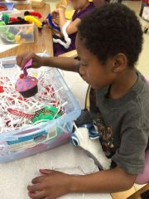We also included a play food cupcake with the label “eat me” and a plastic bottle with the word “drink me”.
It was so fun to see what the different students gravitated towards—-everyone had their favorites!
Exploring and interacting with a selected object is a language access point addressed in this box.
Visual discrimination in addition to reach and grasp skills are also addressed while exploring the fun contents of this fun box!

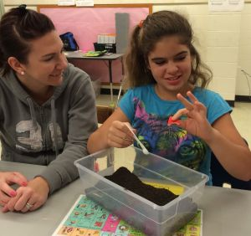A is for Alice and we hid 4 letter A’s in this box of tea leaves. The tea leaves have an interesting texture, kind of crunchy and mild aroma—–a different sensory experience!
The students also had fun using the small scoop to cover them up again.
The math access point recognizing when items have been added to or removed from sets of objects to 4 is addressed here.
Picking up the letters is an opportunity to work on pincer grasp skills—–most beautifully illustrated by this picture—and eye hand coordination.

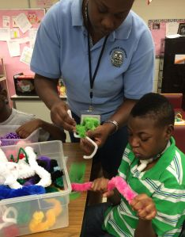Chenille stems make for great caterpillars! This box was filled with regular size and giant size ones for some size comparisons. Soft and colorful—-you just HAVE to reach out for one!
These are perfect for twisting together (and promoting bilateral coordination) to make some new creations—-sensory group meets fine motor group
This also addresses the science access point of recognizing a change in a object.
All the different colors and sizes help address the science access point of identifying common objects by one observable property, such as size or color.

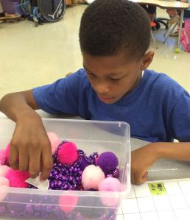Pink and purple are the theme of this next box—-for the Cheshire Cat, of course! All that was left was his grin!
We used a Mr. Potato head mouth for the grin and hid it in the hard beads and soft pompoms
This box addresses the science access point of identifying common objects by one observable property such as size or color.
Recognizing common 3-dimensional objects, such as balls (spheres) and two objects that are the same size or color are math access points addressed here.

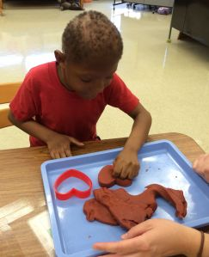We used black cherry kool-aid to make the perfect red for our Queen of Hearts playdough. It turned out really well, a perfect squishy texture! Not only did it look pretty but it smelled wonderful also!
We used our heart shaped cookie cutter to cut out lots of pretty hearts.
Counting how many hearts were cut out addresses math skills and one to one correspondence.
It also addresses the math access point of recognizing 2 dimensional shapes that are the same shape and size (congruent).
The science access point of recognizing a change in an object is also addressed.

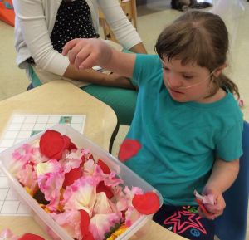These flowers didn’t sing but our students sure had fun making them dance in the air!
Tracking objects that fall to the ground and indicating that an object has fallen are the science access points addressed here.

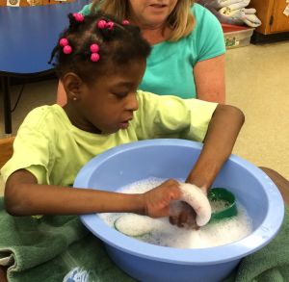Continuing with our floral theme, the students had fun with our sweet pea scented water. We put 2 different size measuring cups for scooping fun…….but sometimes it’s just more fun to play with the bubbles!
Recognizing water as a liquid is the science access point addressed here.
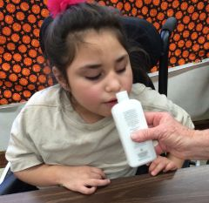We finished with some Crabtree and Evelyn rose scented lotion. Wow this stuff really had a strong aroma. Some of our students really like it…………
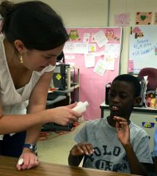Others not so much
Either way, it made for a memorable experience—–and an opportunity to address the science access point of recognizing and responding to one type of sensory stimuli.

FINE MOTOR GROUP
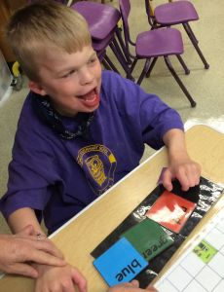On Tuesday we made some Mad Hatter hats! These were assembled by gluing a paper bowl onto a paper plate. We cut a hole in the plate to help it fit onto our students heads.
We had one of our students decide what color to start with and began painting. Jeannie’s favorite color is purple—-hmm, I think someone is looking for extra brownie points from his teacher
The different colors were then passed around so that everyone ended up with a very colorful hat.
Adjusting nonverbal expression, referent objects to communicate wants and needs to familiar persons is a language access point.

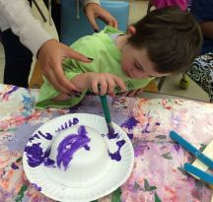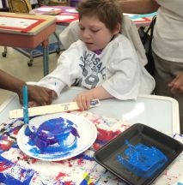Everybody had a great time painting their hats.
The paintbrushes were taped to paint stirring sticks to adapt them for our students with physical disabilities.
The science access points sharing objects with a partner and recognizing a change in an object are addressed with this activity.

Ta DA!
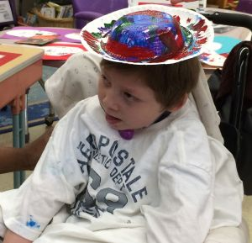 Love it!!!! This Mad Hatter is ready for the tea party!

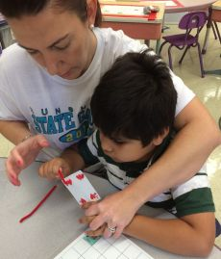On Thursday we made some card soldier puppets. We pulled some of the heart (of course!) cards from a deck. 4 holes were punched and a popsicle stick was glued to the back.
The rectangle shaped cards were counted as they were passed out and then we counted out 2 chenille stems for each student.
We also counted the number of hearts on each card.
Recognizing common objects with two dimensional shapes and associating quantities with number names are math access points.
Chenille stems were threaded through the holes to make the arms and legs. Pincer grasp, eye hand coordination, bilateral coordination—–a PERFECT fine motor activity!

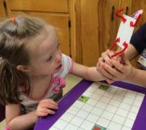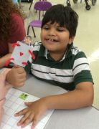These were a huge hit, our students loved their puppets!
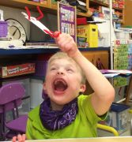Recognizing that the appearance of an object has changed and recognizing one or more external body parts are science access points addressed here.
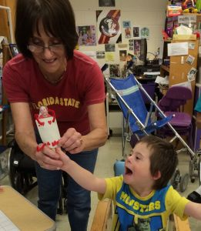 Did we mention our students LOVED their puppets

LANGUAGE GROUP
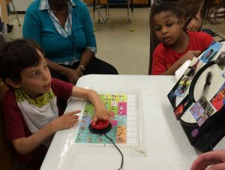We placed pictures from our book on the All Turn it Spinner. With each turn, our students got to try on a costume prop that matched the character.
Using nonverbal expression, gestures/signs, pictures, symbols, or words to responds to familiar read-aloud stories by identifying characters, objects, or events is a language access point addressed here.
Responding to a technology resource is another language access point addressed here.

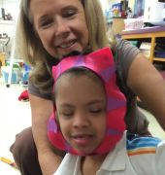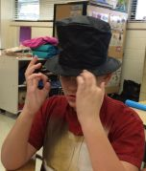Some of the props we used were the Queen of Hearts scepter, Dormouse ears, Cheshire Cat mask, Mad Hatter hat,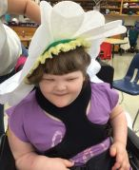 a Singing Flower hood……………………..

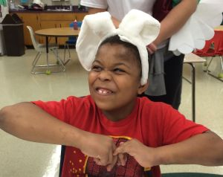AND some White Rabbit ears! This student really got into character, making sure we took a picture of his rabbit impersonation
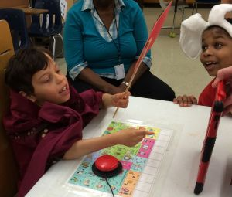We held up a mirror for our students to be able to see themselves, and BOY what a hit that was! The students who were verbal expressed WHAT they had on and WHO they were while the nonverbal students followed directions with prepositions such as “hold it UP”, “put it ON”.
Selecting a familiar object to explore and communicating about the selected object using nonverbal expression, gestures/signs, pictures, symbols, or words is the language access point addressed with this activity.
The students had a great time and the adults in the room definitely enjoyed themselves as well.
REALLY—–who doesn’t love to dress up!?

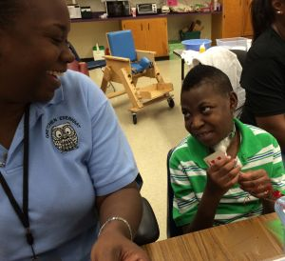That’s it for this week, we had so much fun going down the rabbit hole with Alice and making a wonderland of experiences for our students!
If you are looking for some more traditional October themes—be sure to check out what we did last year—–BUT don’t forget to join us again next week for more Group by Group fun!

